**LAB ASSIGNMENT # 2**



**Course Name:**

**Mobile App Development**

**Submitted to:**

**Sir. Muhammad Kamran**

**Submitted by:**

**Taib-ul-Wara**

**Reg-no:**

**Sp20-bse-021**

**DEPARTMENT OF COMPUTER SCIENCE**

**Comsats university Islamabad, Attock Campus**

**Select a screen from the link below.**

[**https://www.pinterest.com/r743780/sign-up-login/**](https://www.pinterest.com/r743780/sign-up-login/)

**Upload the image of the screen you selected in your Assignment-2 folder.**

**Design this screen in react native.**

**Upload the End result of your design in your repo.**

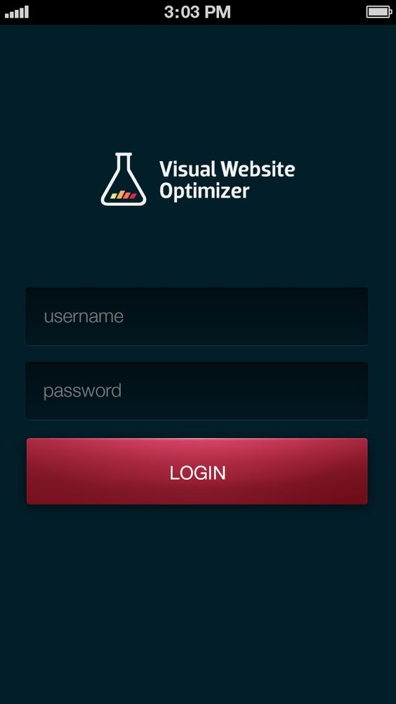

**CODE:**

import React from 'react';

import { StyleSheet, Button, View, SafeAreaView, Text, Alert } from 'react-native';

const Separator = () => (

  <View style={styles.separator} />

);

const App = () => (

  <SafeAreaView style={styles.container}>

    <View>

      <Text style={styles.title}>

       <i> Visual Website</i><b>Optimizer</b>

      </Text>

    </View>

    <Separator />

      <View style={styles.Button}>

        <Button

          title="Username"

          onPress={() => Alert.alert('Username button pressed')

        }

        />

        <Separator />

        <Button

          title="password"

          onPress={() => Alert.alert('password button pressed')}

        />

      </View>

  </SafeAreaView>

);

const styles = StyleSheet.create({

  container: {

    flex: 1,

    justifyContent: 'center',

    marginHorizontal: 16,

    backgroundColor:"blue",

  },

  title: {

    textAlign: 'center',

    justifyContent:"top",

    marginVertical: 10,

    marginHorizontal: 10,

    color:"Red",

    fontSize:120,

    fontStyle:"normal"

  },

  Button: {

    flexDirection: 'colomn',

    justifyContent: 'space-between',

    fontSize:90,

    color:"black",

    marginVertical: 200,

    marginHorizontal: 500,

    width:"10",

    height:"10",

    borderWidth: 0.5,

    height: 100, marginTop: 10,

  },

  separator: {

    marginVertical: 10,

    borderBottomColor: '#black',

    borderBottomWidth: StyleSheet.hairlineWidth,

  },

});

export default App;

**Output:**

